*Florida International University*

*School of Computing and Information Sciences*

CIS 4911 - Senior Capstone Project

Software Engineering Focus

Feature Document

User Story #563

**Team Member:**

Andrew Mitchell

**Product Owner(s)**:

Francisco R. Ortega

**Mentor(s)**:

Francisco R. Ortega

...

**Instructor**: Masoud Sadjadi

# 

# **User Story – Create a Rectangle Shape**

* As a User I would like to implement a rectangle shape so I can draw a smooth rectangle.

## **Use Case – Draw Rectangle**

Use Case

Create a Rectangle Shape

Details:

Actor: User

Pre-conditions:

Touch screen working.

‘Enable rectangle mode’ (key ‘o’)

Program Running.

Description:

Use case begins when a user presses a key (o, Temporary until design philosophy is completed). This will alter the touch screen to draw rectangles instead of lines.The user story ends when the user successfully draws a rectangle and lets go.

Post-conditions:

Rectangles will be drawn on the touchscreen

Can be filled rectangles if filled mode is on.

Decision Support:

Frequency: Very High. Drawing smooth boxes are highly useful.

Criticality: High. Enables more ways to paint on the canvas smoothly.

Risk: low. Team member needs to learn to use the rectangle shape specifically.

Constraints:

Usability:

Just need to learn the proper keybinding.

Reliability: Very Reliable.

Mean time to Failure – Should only fail in extreme conditions. (Keyboard input overloads etc).

Availability – Always available (may change at a future date).

Performance:

Boxes should be drawn smoothly when we drag your finger.

Supportability:

Must work with ACER Multitouch.

Modification History:

Owner: Andrew Mitchell

Initiation date: 02/5/2016

Date last modified: 02/14/2016

**Use Case Diagram**

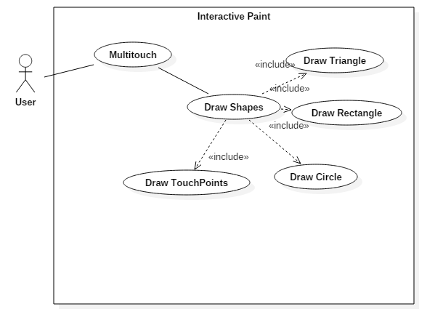

## **Sequence Diagram**

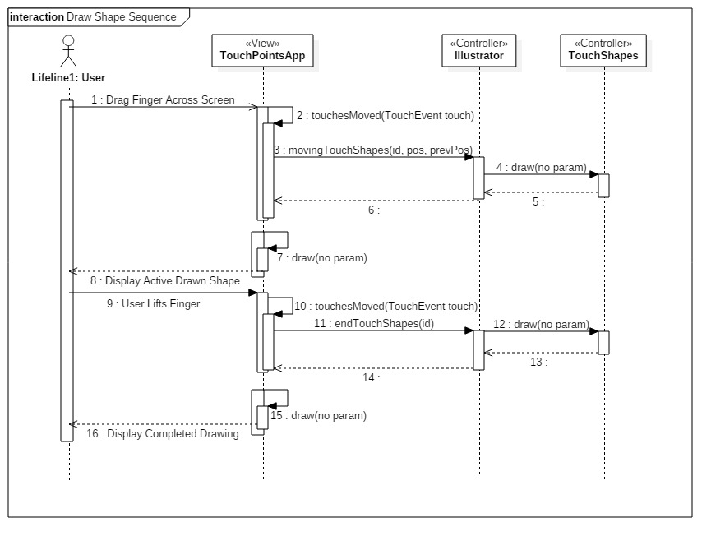

## 

## **Class Diagram**

## 

## **Unit Test**

Sunny Day Tests

Test Case: Draw a Rectangle

Test Purpose:

Ensure we can draw a rectangle shape

Test Setup:

1. Press the shapes button at the top left
2. Press the rectangle button
3. Drag finger across multitouch

Test Output:

After dragging finger across multitouch we drew a rectangle

Expected Output:

Dragging your finger should create a rectangle.

Rainy Day Tests

Test Case: Return to line draw

Test Purpose:

Ensure we can change back to drawing lines

Test Setup:

1. Press Shapes buttons at the top left
2. Press rectangle button
3. Press line button
4. Drag finger across multitouch

Test Output:

Drew a line

Expected Output:

Should draw a line, not a rectangle.

## 

## **Integration Test**

Currently works with all color implementations.

Currently works with Leap Motion device.

Currently works with Real Sense Draw.

Currently works with Multitouch draw.

## 

## **User Guide**

Use the shapes button at the top left to change to a rectangle shape.

Drag your finger across the multitouch to draw a rectangle!

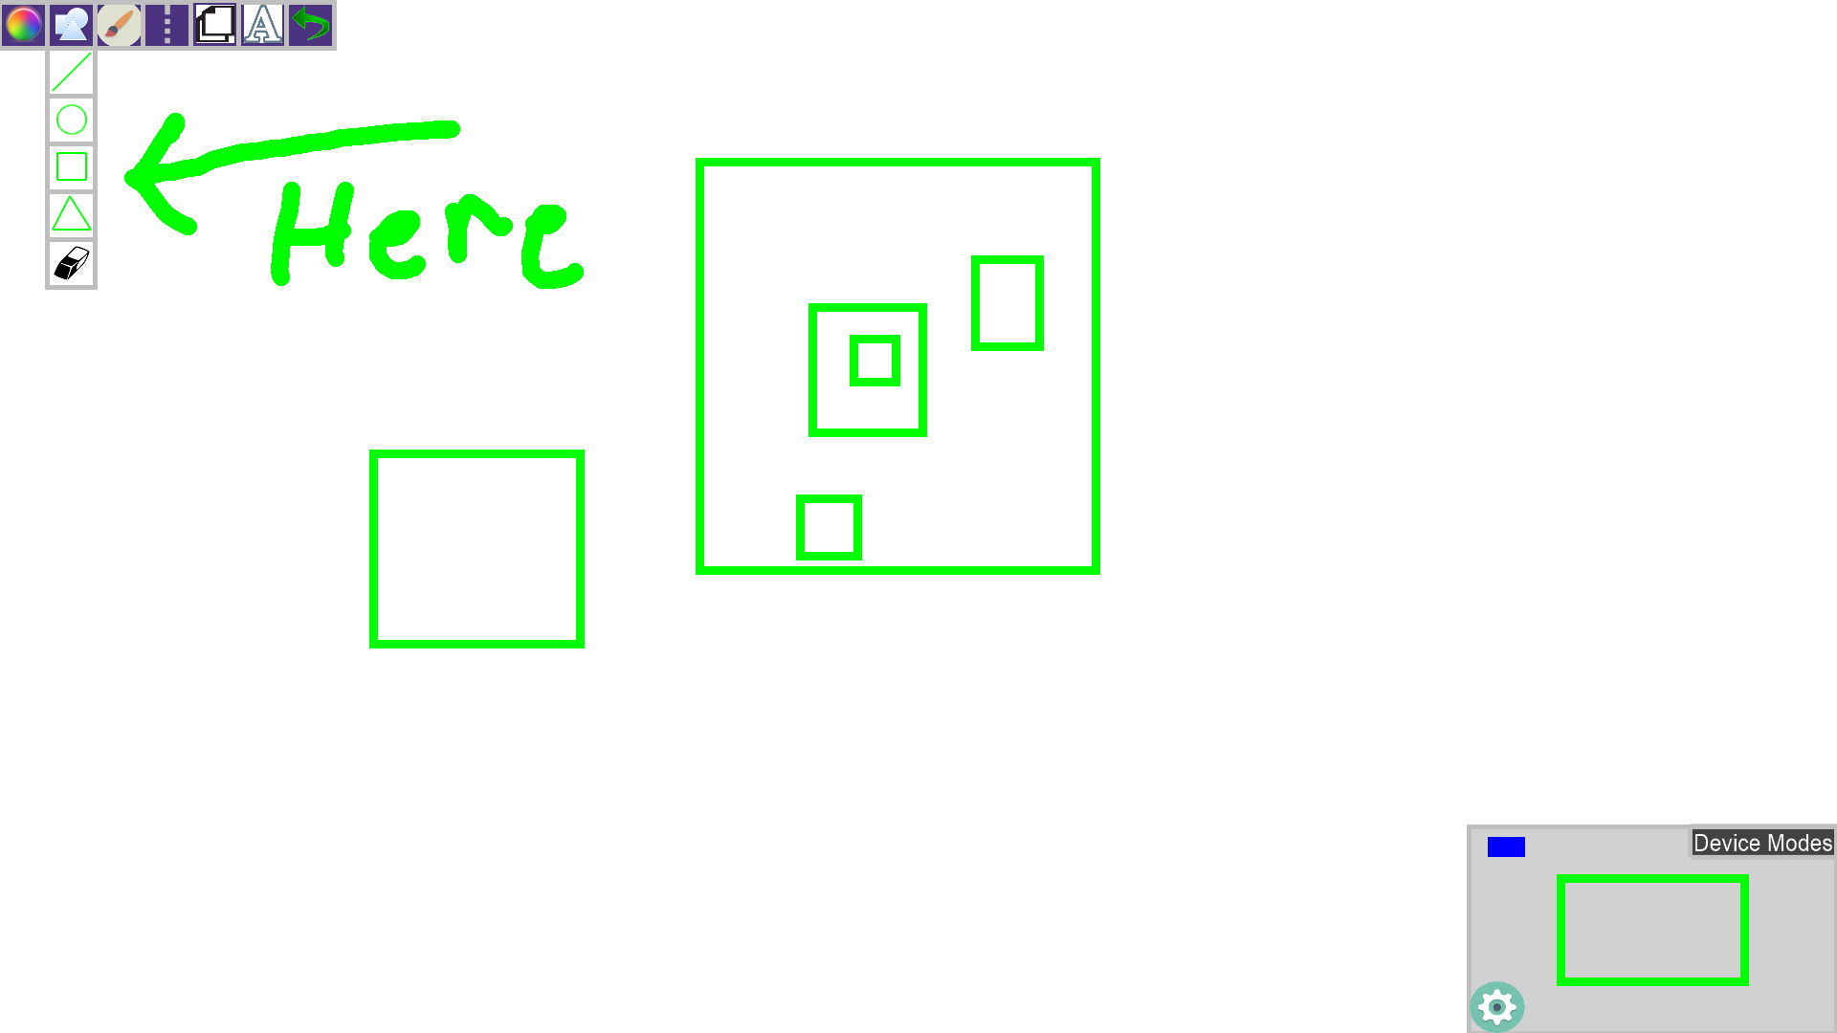

**Glossary**

TouchRectangle – TouchShape which our illustrator can use to draw rectangles